1. Create a “UserLoginModel” class with email and password
2. Implement a filter which should intercepts when user performs login.
3. 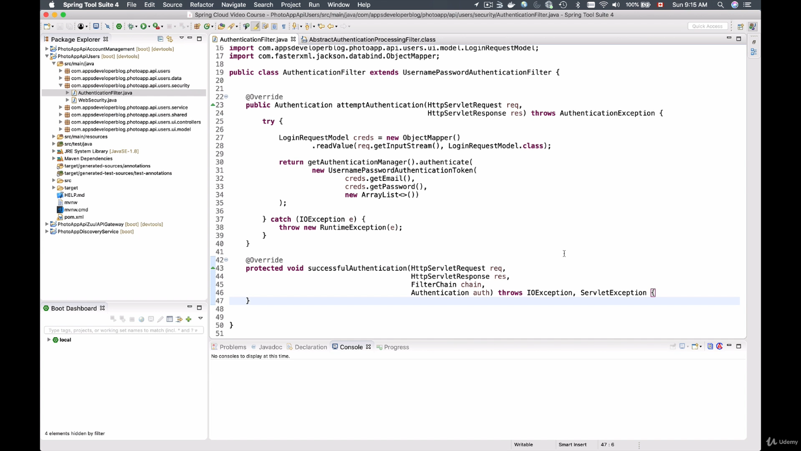
4. Register this filter in Spring Security.

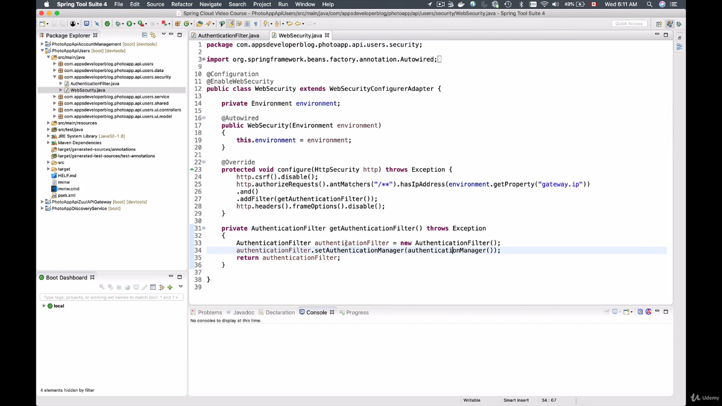

5) Check whether the user entered username and password is available in DB or not using the LoadUserbyUsername();

Override the configure Authentication Manager Builder and call the userDetailsService and create the Bean and inject it into config class

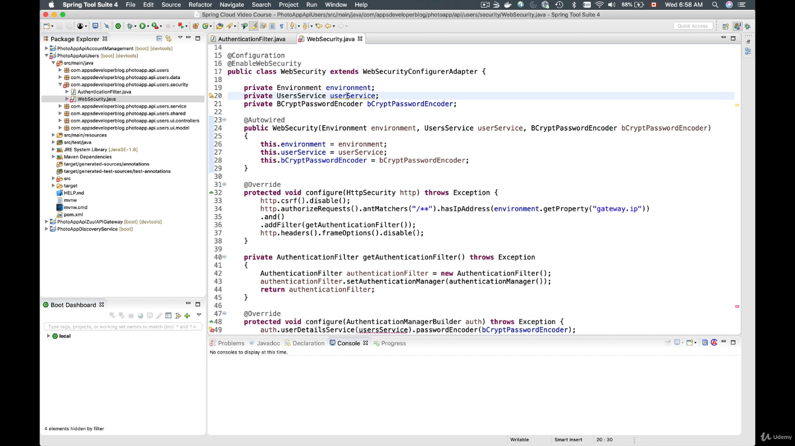

Implement the userDetailsService interface in Service class and override the loaduserByUsername method.

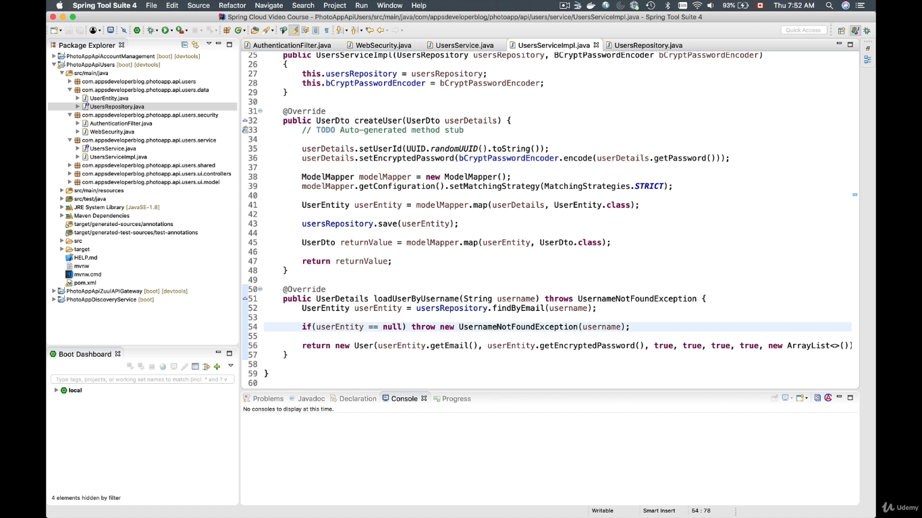

Run the application and try to login.

Now try to generate the JWT Token.

1. Insert the jwt dependency

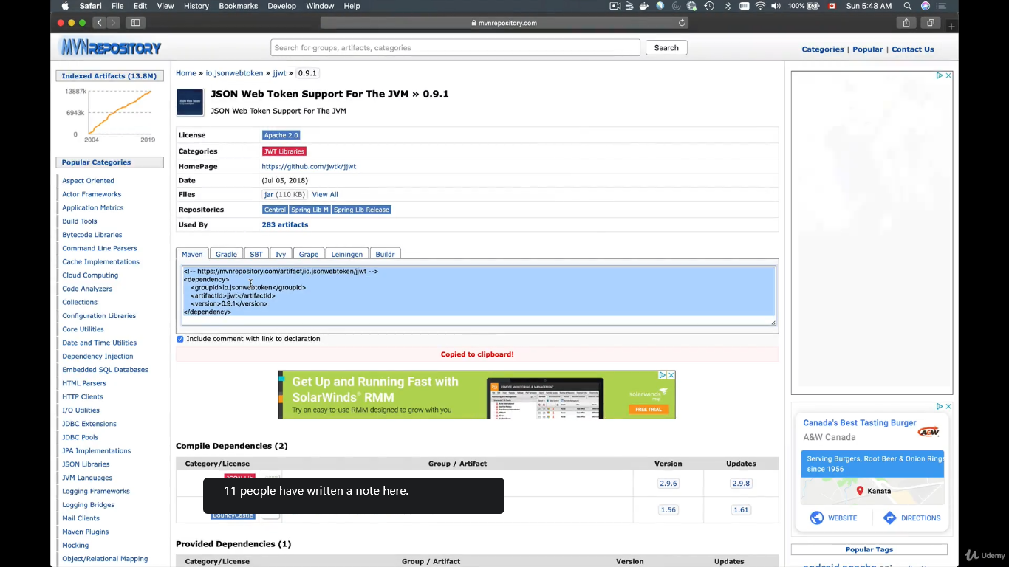

Code for generating the token.

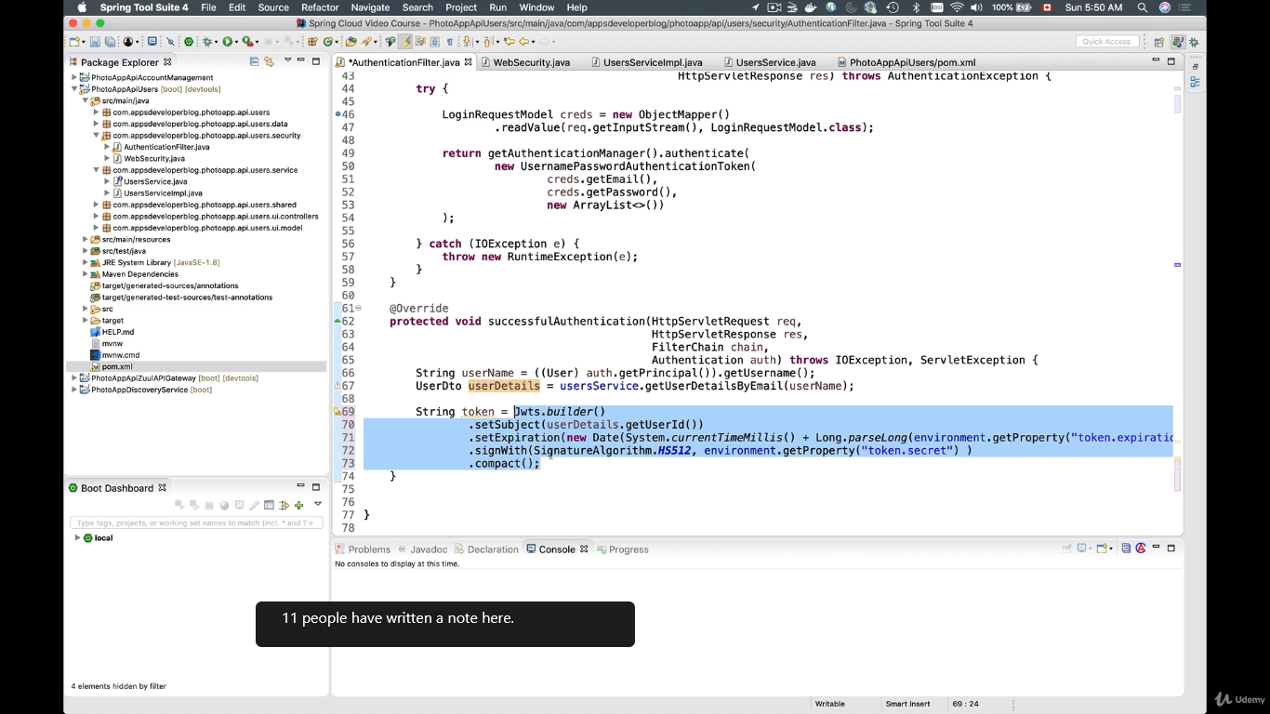

Token expiration time in milli

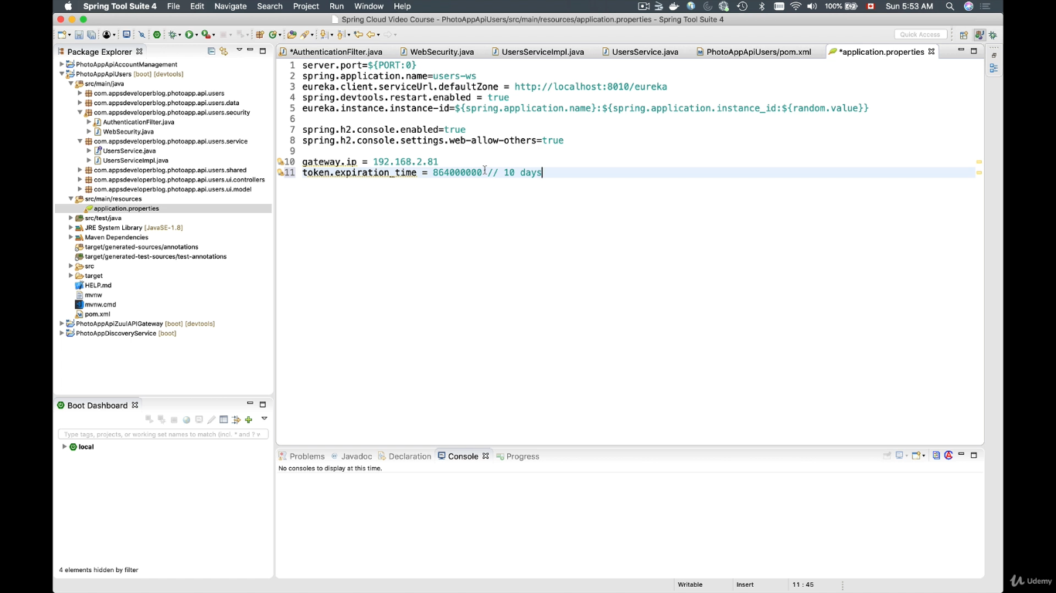

Add JWT to http response headers.

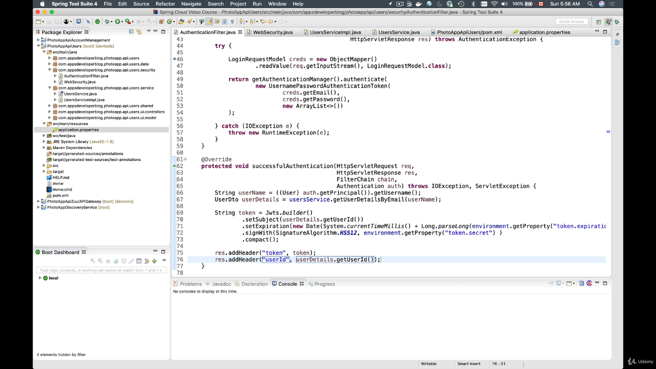

Run our application to check whether we are generating the JWT token.

Customize user authentication URL

